**Database Documentation**

**Student Name** : Adam Waleed, Zeyad Maged, Alaa Mahmoud, Retaj Kaleed, Habiba Mohamed

**Report title**: School Mangment System

**Date:** 24/11/2023

# Purpose and Scope

# Purpose of the Database:

* ● School Management system will help You to manage daily school activities like Student registration, Subject Assign Teachers with Subject, Teachers management, Student Grads, Student Exam , leave management system.

# Scope:

● Helping the school stuff to organize the school mangment system .

# Database Design

# Logical Design:

There are Relation between student and school,

There are Relation between student and Application,

There are Relation between stuff and school,

There are Relation between student and school.

# Physical Design:

● 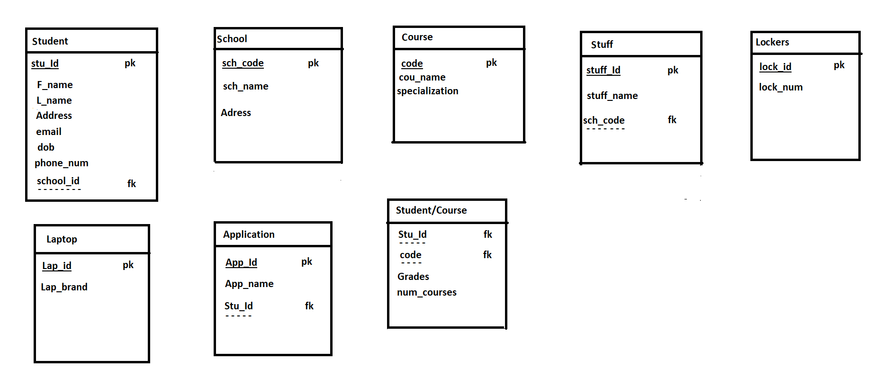

# Data Dictionary

|  |  |  |  |
| --- | --- | --- | --- |
| Field Name | Data Type | Allowed Values | Constraints |
| school_Code | Int | 0 to 2,147,483,647 | Primary key |
| school_name | Varchar | A to Z | Not null |
| school_Address | Varchar | A to Z | Not null |
| Student_id | Int | 0 to 2,147,483,647 | Primary key |
| Student_Fname | Varchar | A to Z | Not null |
| Student_Lname | Varchar | A to Z | Not null |
| student_Address | Varchar | A to Z | Not null |
| student_Phonenumber | Varchar | A to Z | Not null |
| Student_DOB | Date | Year-month-day | Not Null |
| Student_Email | Varchar | A to Z | Not null |
| school_code | int | A to Z | Foreign Key |
| Appliction_id | int | 0 to 2,147,483,647 | Primary Key |
| Appliction_name | Varchar | A to Z | Not null |
| Course_Code | Int | 0 to 2,147,483,647 | Primary key |
| Course_name | varchar | A to Z | Not null |
| Course_Specialization | Varchar | A to Z | Not null |
| laptop_id | int | 0 to 2,147,483,647 | Primary key |
| laptop_prand | varchar | A to Z | Not Null |
| Stuf_id | int | 0 to 2,147,483,647 | Primary Key |
| Stuf_name | Varchar | A to Z | Not null |
| school_Code | int | 0 to 2,147,483,647 | Foreign key |
| lockers_id | Int | 0 to 2,147,483,647 | Primary key |
| locer_num | Int | 0 to 2,147,483,647 | Not Null |

# Database Schema:

* **Entities:**
* School
* Student
* Stuff
* Course
* Laptop
* Lockers
* Application

**Relationship:**

.The Student join **Zero** **or** **One** Application, and application join at least **One** student and at most **One**.

. The Student have **One** School, and School have at least **One** student and at most **Many**.

The Student have **One** Laptop, and Laptop have at least **One** student and at most **One**.

The Student have **One** Lockers, and Lockers have at least **One** student and at most **One**.

The Student Register **Zero or Many** Course, and Course Register at least **One** student and at most **Many**.

The School have **One** or **Many** Stuff, and Stuff have at least **One** School and at most **One**.

**Types of data:**

. Int

. Date

. Varchar

. char

**5- Rules and indexes established (Constraints):**

In table Studentt, the **Student_id**  column constrains (Primary key).

In table Studentt, the **school_code**  column constrains (Foreign key).

In table Schooll, the **school_Code**  column constrains (Primary key).

In table Applictionn, the **Appliction_id**  column constrains (Primary key).

In table Applictionn, the **Student_id**  column constrains (Foreign key).

In table Course, the **Course_Code**  column constrains (Primary key).

In table Laptop, the **laptop_id**  column constrains (Primary key).

In table sStuf, the **Stuf_id** column constrains (Primary key).

In table sStuf, the **school_Code** column constrains (Foreign key).

In table LOKARS, the **lockers_id**  column constrains (Primary key).

**6- Users and their permissions:**

User = ’Adam’

Password = ’123’

**7- Approved by:**

**Eng.Rawan**

**Adam Walled Zeyad maged Alaa mahomed Retaj Khaled Habiba Mohamed**

|  |  |  |  |  |
| --- | --- | --- | --- | --- |
| ERD | 20 Query | ERD on Paper | Edit on Maping to solve some errors | Mapping |
| Plan |  | Solve Errors |  |  |
| Document |  |  |  |  |
| Create Tables |  |  |  |  |
| Insert tables |  |  |  |  |
| 13 Query |  |  |  |  |